I am having trouble uploading sketches from arduino 1.0 and my 3pi robot.  
  
Arduino 1.0  
3pi Robot  
Mega328  
Pololu USB AVR programmer

### Program: Blink Example from pololu: Open the Arduino IDE and create the following sketch:

[?](http://www.pololu.com/docs/0J17/4)

|  |  |
| --- | --- |
| 1 2 3 4 5 6 7 8 9 10 11 12 13 14 15 16 17 18 19 20 21 22 23 24 25 | /*  * Blink  *  * The basic Arduino example, modified to work for Orangutans.    * Turns on an LED for one second, then off for one second,   * and so on...  We use pin 1 because Orangutans have an LED  * on PD1, which corresponds to Arduino pin 1.  *  * <http://www.arduino.cc/en/Tutorial/Blink>  */   int ledPin = 1;                 // LED connected to digital pin 1 (PD1) on Orangutans   void setup()                    // run once, when the sketch starts {   pinMode(ledPin, OUTPUT);      // sets the digital pin as output }   void loop()                     // run over and over again {   digitalWrite(ledPin, HIGH);   // sets the LED on   delay(1000);                  // waits for a second   digitalWrite(ledPin, LOW);    // sets the LED off   delay(1000);                  // waits for a second } |

I know the code says its for orangutans, but this note is included with the code: *Please note that if you are using a 3pi and have not yet soldered in the optional through-hole LEDs, you will need to look at the underside of the robot to see the flashing LED.

I followed all of these instructions <http://www.pololu.com/docs/0J17/4> (selected the right board/programmer/serial port), But when I hit upload, the adruino interface shows me this:

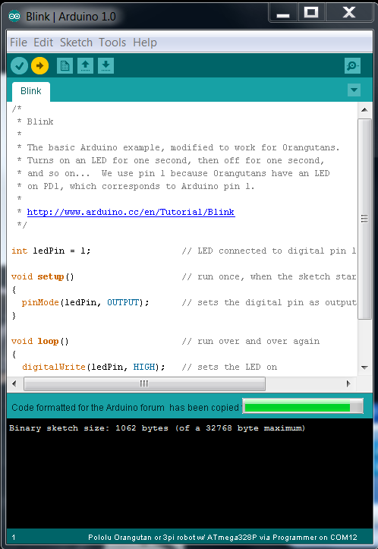

…And my robot isn’t blinking an LED. I’ve waited for a long time and still nothing. Any ideas?  
  
  
  
Problem update:  
  
Sometimes the program appears to finish uploading, only to display this error (and no blinking LED!):  
  
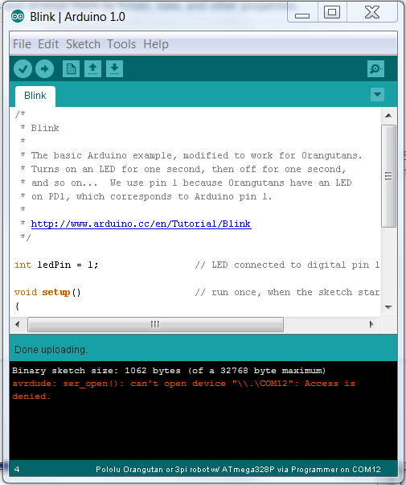

Currently researching what the error means and how to fix it…